DECODE THE CHART

Name: Manisha M Roll no: 24
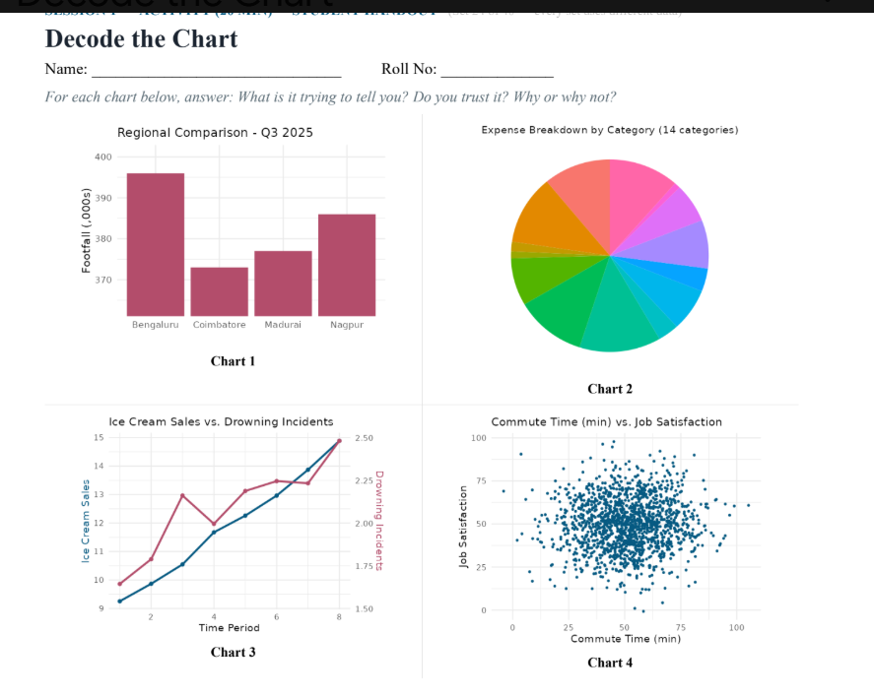
Chart 1: Regional Comparison - Q3 2025
What is it trying to tell?
Bengaluru had significantly higher footfall in Q3 2025 compared to Coimbatore, Madurai, and Nagpur, suggesting a massive disparity in performance across regions.
Do you trust it? No.
3 Why or why not?
The y-axis is truncated (it starts at 370 instead of 0). This visually exaggerates tiny relative differences. For example, Bengaluru's footfall (~395,000) appears nearly 4 times larger than Coimbatore's (~372,000), whereas the actual difference is only about 6%.

Chart 2: Expense Breakdown by Category (14 categories)
- What is it trying to tell? It attempts to show the proportional distribution of spending across 14 distinct expense categories.
- Do you trust it? No.
- Why or why not? Pie charts become unreadable and misleading with too many slices (14 categories here). Several thin slices are visually indistinguishable, making it impossible to assess proportions accurately, especially without slice labels or percentages. A horizontal bar chart would represent this data far better.
Chart 3: Ice Cream Sales vs. Drowning Incidents
- What is it trying to tell? Ice cream sales and drowning incidents track each other almost identically over time, implying a strong link between the two.
- Do you trust it? No.
- Why or why not? This is a classic "Correlation does not imply Causation" fallacy. Both variables are driven by a lurking third variable: temperature/seasonality. During summer months, warm weather increases both ice cream consumption and swimming activity (which leads to more drowning incidents). Selling ice cream does not cause drownings.
Chart 4: Commute Time (min) vs. Job Satisfaction
- What is it trying to tell? It plots individual data points to show whether longer daily commute times affect overall job satisfaction.
- Do you trust it? Yes (as a valid representation showing no correlation).
- Why or why not? The chart uses an untruncated scatter plot displaying a random "cloud" of data points spread evenly across job satisfaction scores regardless of commute duration. It accurately communicates that there is no meaningful statistical relationship between commute time and job satisfaction in this dataset.

